Software Requirement Specifications
Online Tourist Guide



Submitted by:
Muhammad Ubaid Akbar
Roll No.
F22BINFT1M01173
Submitted to:
Ms. Sara Farid

Department of Information Technology Faculty of Computing

The Islamia University of Bahawalpur

Meeting Details

Sr No | Details | Date | Supervisor  Signature

Summary

The Online Tourist Guide is a web-based designed to assist tourists in exploring, planning, and navigating tourist destinations efficiently. The system provides comprehensive information about tourist locations, allowing users to search, view, and select destinations before and during their visits. The project aims to simplify tourism-related activities by offering an interactive and user-friendly platform accessible from anywhere in the world.

The system operates through two main components. The first component is a web-based application that enables users to browse tourist locations, view packages, and set personal travel preferences such as visit duration and preferred locations. The second component supports mobile usage, where users can access location information during travel. With the help of GPS functionality, the application can automatically display relevant information about nearby locations without requiring user intervention. Additionally, the system supports offline access, allowing users to view stored data when an internet connection is unavailable.

The Online Tourist Guide includes two primary user roles: Admin and User. Administrators manage the system by adding, updating, and deleting tourist locations, packages, and user records. Users can register, log in, search tourist places, view packages, and even create customized tour plans. Guest users can also access basic information without registration.

Developed using PHP, JavaScript, AJAX, and MySQL, the system ensures secure data handling, reliable performance, and ease of use. Overall, this project provides a flexible, scalable, and efficient solution for modern tourism needs, making travel planning easier and more accessible for users worldwide.

Table of Contents
- Introduction 1
  - Purpose 1
  - Scope 1
  - Definitions, Acronyms, and Abbreviations. 1
  - References 2
  - Overview 2
- The Overall Description 3
  - Product Perspective 3
  - Product Functions 3
  - User Characteristics 3
  - General Constraints 3
  - Assumptions and Dependencies 4
- Specific Requirements 4
  - External Interface Requirements 4
    - System Interfaces 4
    - Interfaces 4
    - Hardware Interfaces 4
    - Software Interfaces 5
    - Communications Interfaces 5
  - Functional Requirements 5
    - <Functional Requirement of SignUp> 5
  - Use Cases 5
  - Classes / Objects 8
  - Non-Functional Requirements 9
  - Inverse Requirements 9
  - Logical Database Requirements 10
  - Design Constraints 11
    - Standards Compliance 11
Parent Component: 11
Software Language 11
- Analysis Models 12
  - Sequence Diagrams 12
  - Data Flow Diagrams (DFD) 16
  - State-Transition Diagrams (STD) 17
- Supporting Information 18
Appendix A – Background Research on: 18

Introduction

Purpose
Now a day’s people use mobile devices and mobile phones. People use these gadgets for calling, as a calendar, planner and organizer. Mobile phones with GPS facility are also used to find paths in navigation. The main idea of this project is to design the system that will run on mobile phones, which will be helpful when visiting some new places. The proposed mobile tourist guide design consists of two steps, the first step is designing a web site that allows the user to navigate a web site, discover the locations and the interesting points before the real visit. The second step is designing the mobile applications. When the user visits the web site, selects the points that he wants to visit and specifies some preferences such as the visit duration, the mobile model, and the language, then the information about these locations are kept over the user space and an application is being built. The application must be now installed in his mobile phone. The user runs the application while visiting. He accesses the information from a simple interface or the information about any location is displayed without the user intervention according the GPS positioning system, where the matching is done between the GPS coordination and the GPS dimensions stored for each location over the device. If so, the information about this location is displayed. The system is designed to allow tourist to work in on-line from the web site or off-line mode from the installed application over the mobile device.

Scope
- Web Based Application
- Easily use from Admin side and User Side.
- Secure Application has vast scope in tourism industry
- Access anywhere in the world
- View in mobile phone also.

Definitions, Acronyms, and Abbreviations.

Term | Description
GUI | Graphical User Interface
Interactive system | A system which allows user to manipulate settings.
FAQ | Frequently asked questions
Admin | Administrator.
SRS | Software Requirement Specification
OTG | Online Tourist Guide

References
- www.google.com
- www.w3school.com
- www.cs.unc.edu/~stotts/145/CRC/state.html
- https//openai.com

Overview
This application is web based application. This application will solve our tourism issues. After using our application user easily search and view tourist places easily. Tourism is a vast industry in the world. Most of the people like to visits different places. So our application is most beneficial for these industries.

The Overall Description
This section includes all the requirements of our application like signup, login, make tours, view tours and also select tours.

Product Perspective
Our application has two side user’s sides, admin sides. Every Side User makes their tasks well and better style.

Product Functions
- The web site allows the user to register and provide his preferences.
- The user can also access the information without registering [as visitor]
- The database contains all the desired information about locations and users.
- Admin rights allow users to add new data or update existing data in the database.
- The web service is built to provide services for users who install the application over their mobile device. The user can access the information from the local storage in case of offline or update the local storage with information from the server on online case. This component helps the user to build an application in his mobile device to be used in case of disconnection or under the user demand.

User Characteristics
The typical CECS user is simply anyone that has access to the Internet and a web browser in the computer science department at Michigan State University. It is assumed that the user is familiar enough with a computer to operate the browser, keyboard and mouse and is capable of browsing to, from and within simple websites.

General Constraints
- Accessibility: User easily open the application
- Memory constraints: PC,laptop must have 512 mb Ram.
- Tools: web application is built by using PHP, Java Script, AJAX..

Assumptions and Dependencies
For developing this type of web based application we need a web server, a web browser, internet facility, laptop or PC or mobile. If any one of them are missing then our system not working correctly.

Specific Requirements

External Interface Requirements
    - System Interfaces
- Project Interactivity Plan
- Secure User Login
- Login Information:

    - Interfaces

System should be able to provide SignUp
System should be able to provide Login
System should be able to view tourist packages
System should be able to select packages
System should be able to make user their own tourist package
System should be able to Delete user’s account from the admin panel
System should be able to Delete tourist packages detail from admin panel
System should be able to view user’s personal packages and respond.

    - Hardware Interfaces
- Ram 512 mb
- Pantium 4 pc

    - Software Interfaces
- PHP Language
- Web Server
- Windows 7 & Windows 8
      - MYSQL
Our system use MYSQL database for storing data. So MYSQL is a back end database for my project.
    - Communications Interfaces
PHP/MYSQL is our communication interface

Functional Requirements
    - <Functional Requirement of SignUp>
      - Introduction

        - Front end of website.
      - Inputs
        - Add SignUp Data,
        - View Data,
        - Delete Data,
      - Processing
        - Listing all Data.
      - Outputs
        - Signup Successfully

Use Cases


Online Tourist Guide
viewusers
Location
«extends»
Add
Google Map
«extends»
«extends»
Administrator
Login
«extends»
Logout

Online Tourist Guide
SignUp
Location
«extends»
View
Google Map
«extends»
«extends»
User
Login
«extends»
Logout

Classes / Objects

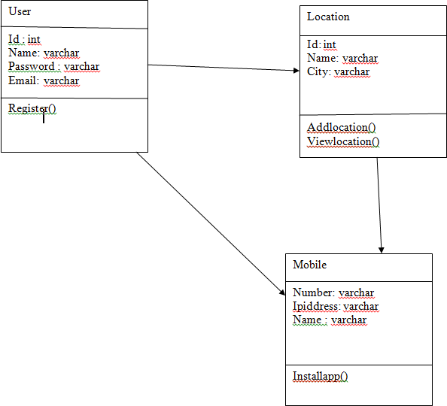

Non-Functional Requirements
System Requirements:
- Memory Requirement = 512MB RAM
- Pentium 4 Processor Reliability Requirements:
  - Web base application shall be a 24x7 application
  - The downtime of system shall not exceed 1 hour Flexibility:
Another Important Characteristics of this project is that it provides flexibility.

Inverse Requirements
It is very significant to keep up capable software to manage information of Online Tourist Guide.This application offer away to record this information and to access these in an easy technique.

Logical Database Requirements
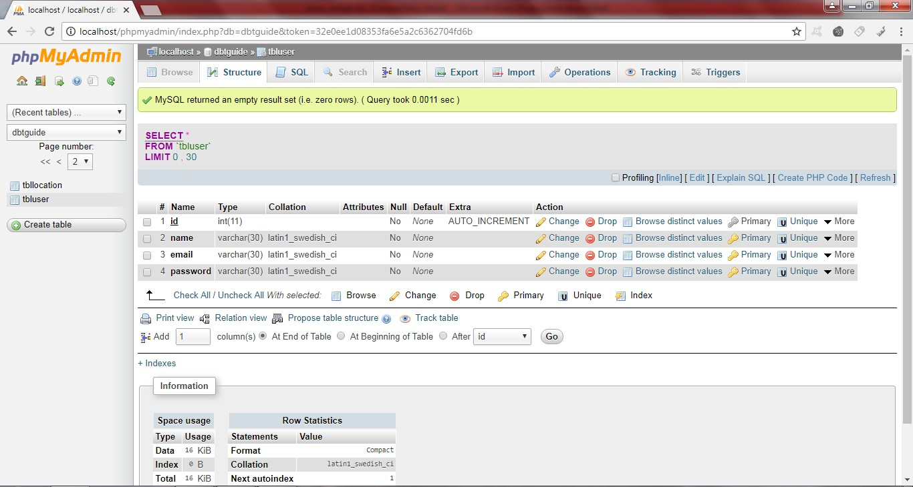

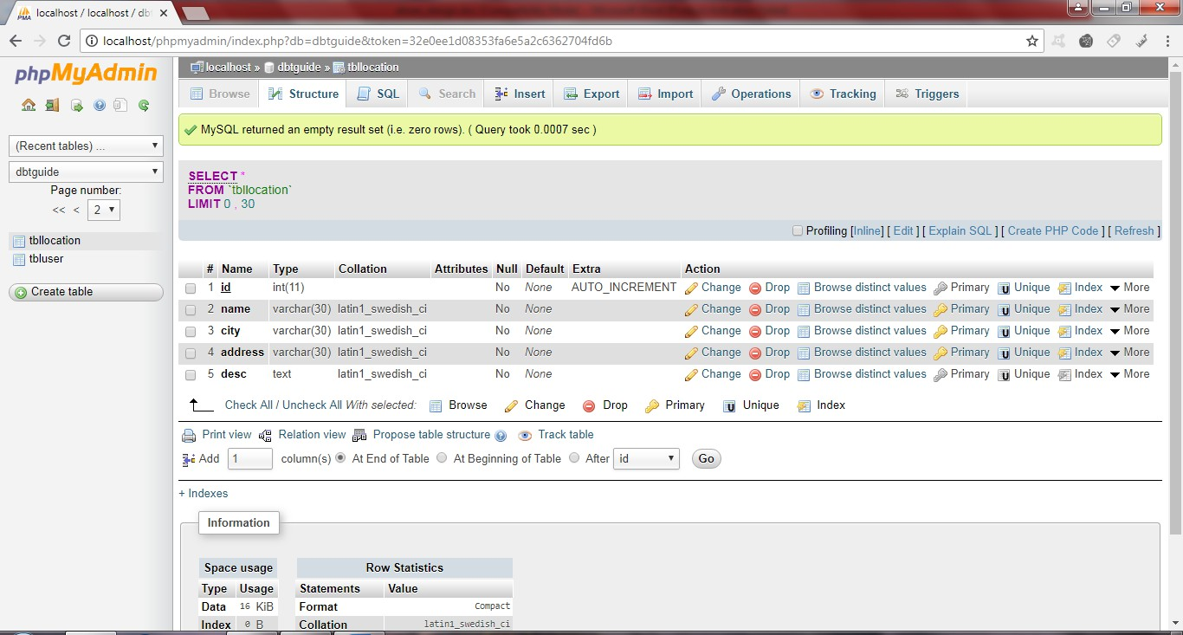

Design Constraints
    - Standards Compliance Parent Component:
This system is focus on the worldtour.com websites.
Software Language:
Php web based language is used to develop this website.

Analysis Models

Sequence Diagrams
Register

process
registerreq()
savetodb()
authentication
user register successfully
Register
Register Database
User

Login

process
loginreq()
showfromdb()
authentication
user login successfully
Login
Register Database
User

Add Location

process
addlocation()
savetodb()
authentication
user add location successfully
Location
Location Database
User

View Location

process
viewlocation()
showfromdb()
authentication
user view location successfully
Location
Location Database
User

Data Flow Diagrams (DFD)
Students
status
Search trip
Make trip
signup
Select location
View location login
Online Tourist Guide
login
Respond user
View location
View user
status
Del user

admin

State-Transition Diagrams (STD)
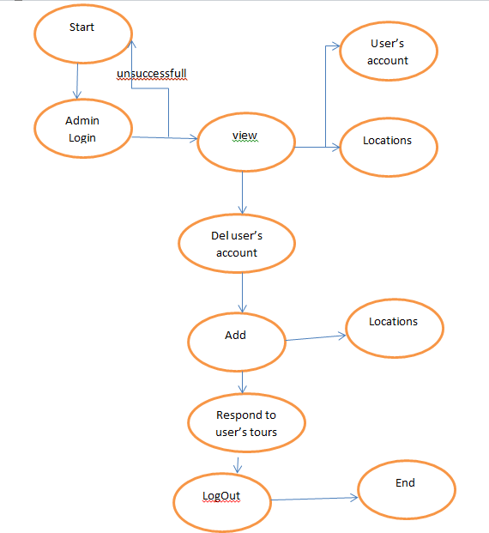

Supporting Information

Appendix A – Background Research on:
Microsoft Windows 7 professional PHP
Mysql Dreamweaver
Microsoft Word 2007
Microsoft Visio 2007 Microsoft Paint

Appendix B – Data Dictionary
http://www.tutorialspoint.com http://www.google.com

